https://www.quora.com/What-are-the-applications-of-AI

******************************************************************************
What are the applications of AI?
The number of artificial intelligence startups has been exponentially growing from the last few years. It has been employed immensely in business for creating smart applications. AI-based products make work easy and somewhat more reliable. The following are the few mind-boggling AI applications from various sectors:
AI is important because it can help solve immensely difficult issues in various industries, such as entertainment, education, health, commerce, transport, and utilities. AI applications can be grouped into five categories:
- Reasoning: The ability to solve problems through logical deduction. e.g. financial asset management, legal assessment, financial application processing, autonomous weapons systems, games
- Knowledge: The ability to present knowledge about the world. e.g. financial market trading, purchase prediction, fraud prevention, drug creation, medical diagnosis, media recommendation
- Planning: The ability to set and achieve goals. e.g. inventory management, demand forecasting, predictive maintenance, physical and digital network optimization, navigation, scheduling, logistics
- Communication: The ability to understand spoken and written language. e.g. real-time translation of spoken and written languages, real-time transcription, intelligent assistants, voice control
- Perception: The ability to infer things about the world via sounds, images, and other sensory inputs. e.g. medical diagnosis, autonomous vehicles, surveillance
AI trends in various sectors
1. Healthcare
AI and ML technology has been particularly useful in the healthcare industry because it generates massive amounts of data to train with and enables algorithms to spot patterns faster than human analysts.
An app called BiliScreen utilizes a smartphone camera, ML tools, and computer vision algorithms to detect increased levels of bilirubin in the sclera (white portion) of a person’s eye, which is used to screen people for pancreatic cancer. This cancer has no telltale symptoms, hence it has one of the worst prognoses of all cancers.
2. Entertainment
A familiar application of AI in everyday life is seen with services like Netflix or Amazon, wherein ML algorithms analyze the user’s activity and compare it with that of other users to determine which shows or products to recommend. The algorithms are becoming intelligent with time—to the extent of understanding that a user may want to buy a product as a gift and not for himself/herself, or that different family members have different watching preferences.
4. Data security
Cyber attacks are becoming a growing reality with the move to a digital world. There are also concerns about AI programs themselves turning against systems.
PatternEx and MIT’s Computer Science and Artificial Intelligence Laboratory (CSAIL) have developed an AI platform called AI2 which claims to predict cyber attacks better than existing systems. The platform uses Active Contextual Modeling, a continuous feedback loop between a human analyst and the AI system, to provide an attack detection rate that is better than ML-only solutions by a factor of 10.
5. Manufacturing
- Landing.ai claims to have created machine-vision tools to find microscopic defects in objects like circuit boards using an ML algorithm trained using tiny volumes of sample images. In the future, self-driving robots may be created which can move finished goods around without endangering anyone or anything around.
- Robots in factories are often stationary but are still in danger of crashing into objects around it. A new concept called collaborative robots or “cobots, enabled by AI, can take instructions from humans, including instructions that the robot has not been previously exposed to, and work productively with them.
6. Automotive industry
- Tesla introduced TeslaBot, an intelligent virtual assistant integrated with Tesla models S and X, allows users to interact with their car from their phone or desktop.
- Uber AI Labs is working on developing self-driven cars with the help of the best engineers and scientists. Uber has already tested a batch of self-driving cars in 2016.
- Nvidia has partnered with Volkswagen to develop “intelligent co-pilot systems” in cars that will enable safety warnings, gesture control, and voice and facial recognition.
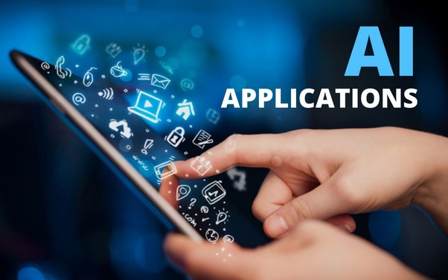
1

Here I will highlight some of the applications on which I have worked so far.
- Stock Price Prediction
- Object Detection
- Edge detection
- Image to Image Translation
- Symbol Detection
- Impairments Estimation
- Chatbots*
- Autonomous Vehicles
- Gaming*
- Healthcare
- Agriculture*
- Space Exploration*
- etc…
